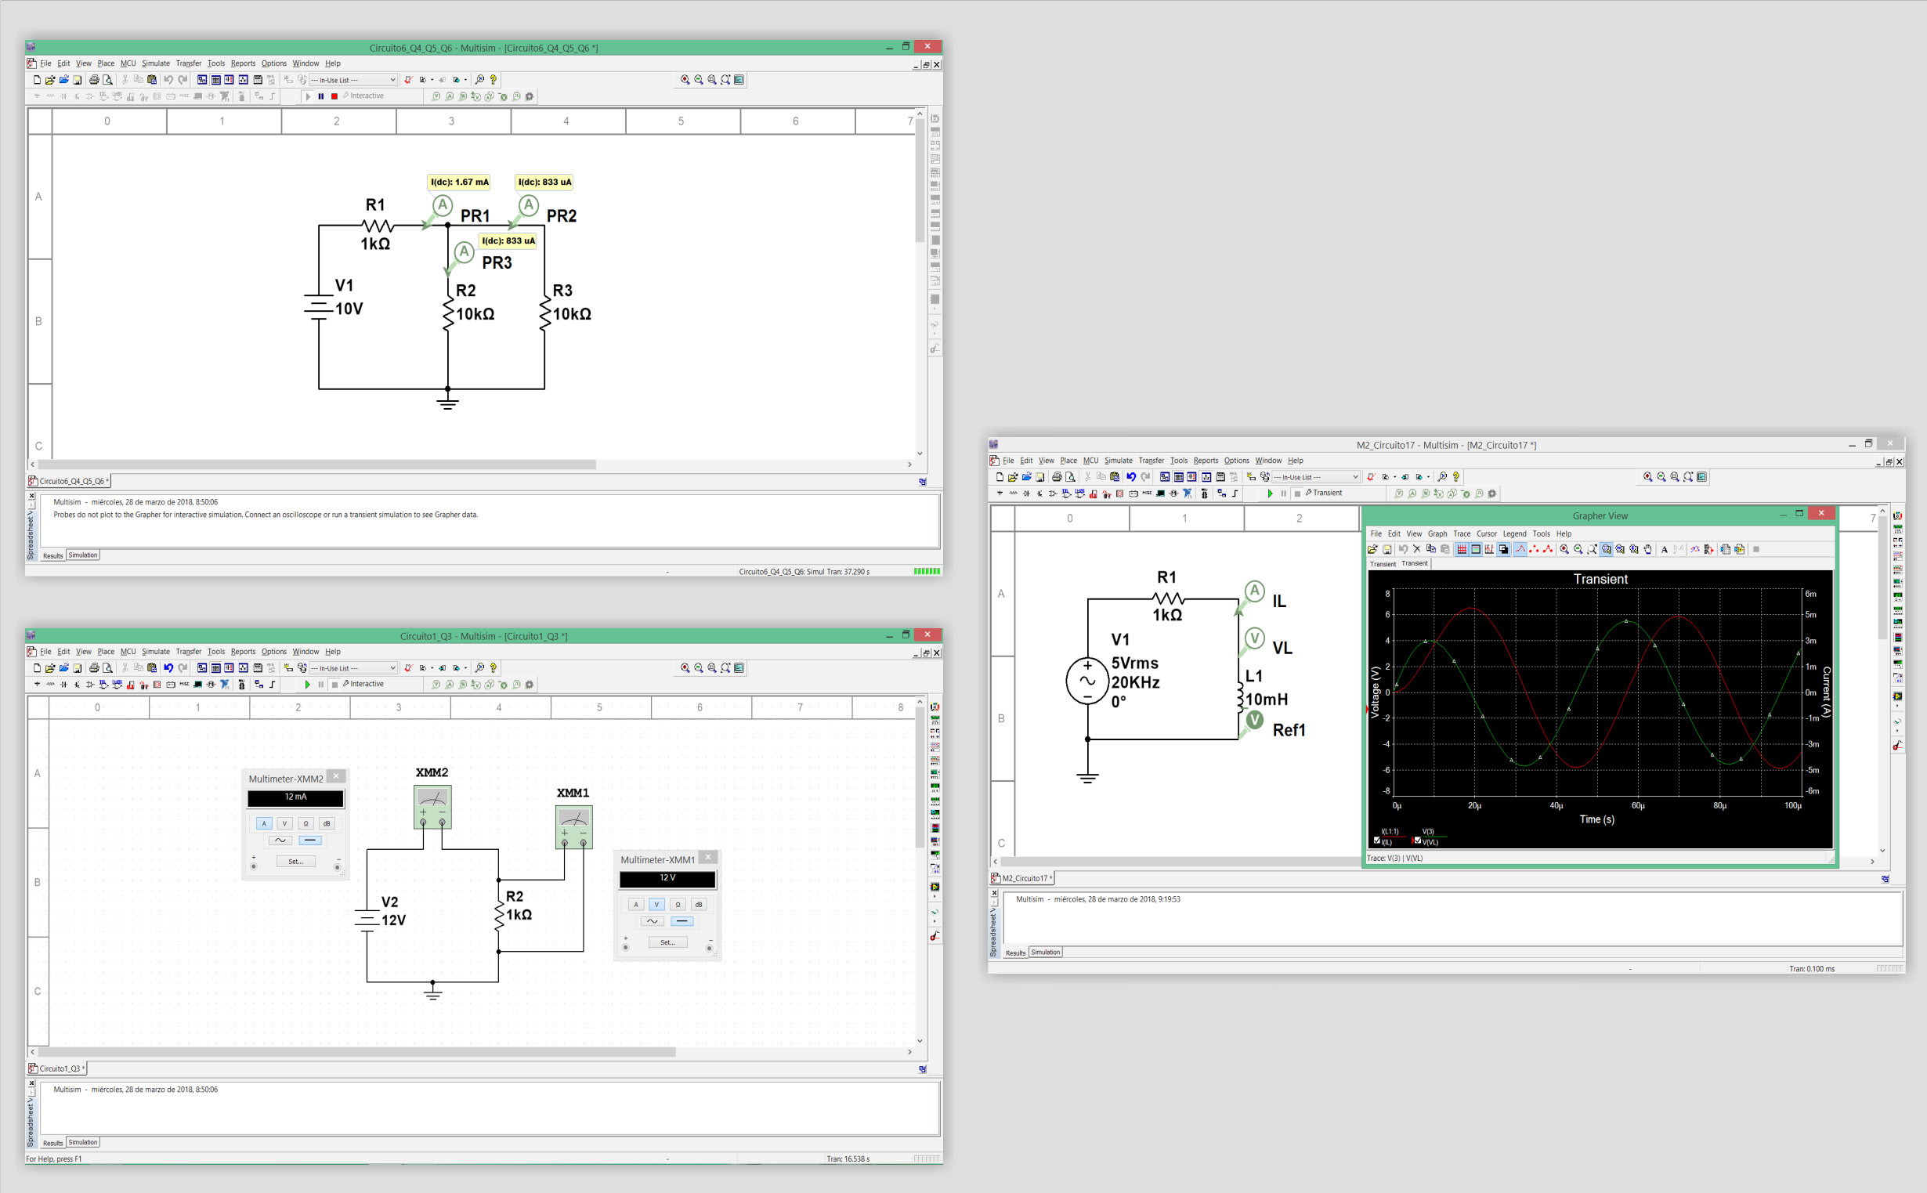

Key features:

- Initiation to the programing field in a practical way with EDIBON TECHNICAL TEACHING EQUIPMENT. Real Hardware development environment using NI LabVIEW™ at engineering R&D levels.

- Open Source Software packages (OSS) custom-developed for each individual unit.

- It will allow the researcher to work with any involved value and parameter without limits.

- Software Development Kit (SDK): set of libraries and practical exercises based on several examples of incremental complexity.
- Edition of NI Multisim™ programs.
- Detailed help documentation introducing all the required concepts and supported on learning resources and guided practical exercises.

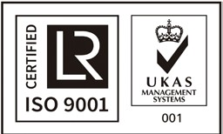

ISO 9001: Quality Management (for Design, Manufacturing, Commercialization and After-sales service)
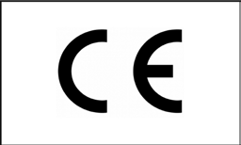

European Union Certificate
(total safety)

Certificates ISO 14001 and ECO- Management and Audit Scheme (environmental management)
1
“Worlddidac Quality Charter” and Platinum Member of Worlddidac

INTRODUCTION

In a design project of electronic or electric circuits, one of the most critical stages is the one aim to foresee the voltages and current in the different parts of the circuit, because depend of this stage are defined the components nominal power, the wire sizes, the isolation requirements, etc. in other words, this stage defines a big part of the project cost.

Nowadays, the complexity of real electronic or electric systems requires of new tools in order to be more efficient an accurate in the circuit calculation, which allows to reduce the project cost dramatically.
One of the most internationally recognized software to design, prototyping, and test electronic and electrical circuits is National Instrument Multisim™. NI Multisim™ offers all the virtual tools required to create, test and analyze your own electronic and electric circuits in order to optimizing the design in the early development stages, saving costs and reducing implementation time. The NI Multisim™ is a complete simulation tool that allows to create hundreds of circuits. To perform from simple tasks like simulate passive electronic components to advanced tasks like simulate control systems with close loop and PID controllers and PCB layouts to generate the fabrication files to manufacture the PCB boards.

GENERAL DESCRIPTION

EDIBON Development KIT for Circuits Simulation, Powered by NI LabVIEW™ ,“EMSK”, is a software package, based on National Instruments Multisim™ environment, offered as an optional item for some EDIBON TECHNICAL TEACHING EQUIPMENT. The “EMSK” is a set of virtual tools aimed to users who need to get started in the fields of virtual designing, prototyping, testing and PCB designing of electronic circuits, including a set of examples with increasing complexity to help the students to perfom from basic to advanced actions.

The “EMSK” offers a complete solution to create, test, analyze and PCB designing of your own electronic and electric circuit designs, the virtual components and instruments included are:

• Complete library of electronic components, more than 36,000, including diodes, logic gates, transistors, filters, different integrated circuit to voltage regulation, temporization, led control, logic control, PID control, system simulation, close and open control loops, etc.

• Virtual components to power supply, digital signal generation, function generation, etc.

• Virtual instruments, with real interface, to perform a complete analysis of the designed circuits: voltmeters, ammeters, oscilloscopes, frequency analyzers, frequency counter, etc.

Additionally, the EDIBON Development KIT for Circuits Simulation, Powered by NI LabVIEW™ includes example circuits in order to test the specific circuits of each EDIBON TECHNICAL TEACHING EQUIPMENT.

SPECIFICATIONS

• EDIBON Software Development KIT requires:

- NI LabVIEW Student or Multisim Software.

- EDIBON TECHNICAL TEACHING EQUIPMENT.

• EDIBON Software Development KIT includes (*):

- Practical exercises to get started with NI Multisim™ environment.

- Practical exercises to get started with EDIBON TECHNICAL TEACHING EQUIPMENT.

- A set of NI Multisim™ circuits to analyze the circuits of the EDIBON TECHNICAL TEACHING EQUIPMENT.

(*) The content may vary depending on the equipment supplied.

POSSIBLE PRACTICAL EXERCISES

1.- Basic practical exercises to get started with NI Multisim™ and build simple circuits.

2.- Basic practical exercises to get started with EDIBON TECHNICAL TEACHING EQUIPMENT.

3.- Simulate a simple RLC circuit.

4.- Voltage and current measurement.

5.- Signal analysis with an oscilloscope.

6.- Diode and rectifiers functions.

7.- Analysis of a NPN transistor with common collector and common emitter configurations.

8.- Analysis of a PNP transistor with common collector and common emitter configurations.

9.- Darlington NPN pair configuration.

10.- Using a virtual function generator to generate a frequency sweep.

11.- Using the bode plotter to analyze the frequency response of a RLC circuit.

12.- Analyze the transient response of a RLC circuit.

13.- Modulating a PWM signal.

14.- BUFFER, NOT, AND, NAND, OR, NOR, XOR and XNOR Logic gates circuits analysis.

15.- PCB Layout and routing of a RLC circuit.

16.- Create to PCB reports of Bill of materials, board statististics, copper calculations, etc.

17.- Create the industry-standard GERBER, DXF, NC drill, etc., format files for PCB manufacturing.

18.- Response of a first order system in time domain (transient response).

19.- Response of a first order system in frequency domain (Bode plot).

20.- PID control of a first order system in closed-loop.

21.- Setting and optimizing the PID controlles parameters for the first order system.

22.- Response of a second order system in time domain (transient response).

23.- Response of a second order system in frequency domain (Bode plot).

24.- PID control of a second order system in closed-loop.

25.- Setting and optimizing the PID controller parameters for the second order system.

EDIBON DEVELOPMENT KIT FOR CIRCUITS SIMULATION, POWERED BY NI LABVIEW™
MAIN SCREENS

Example of the logic gates and transformers library

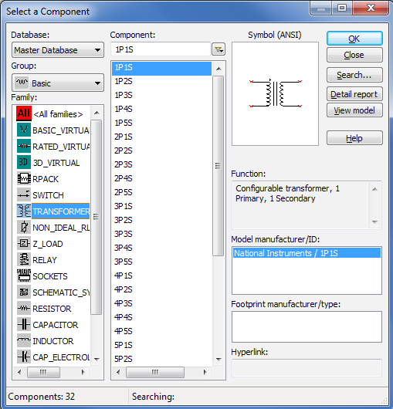

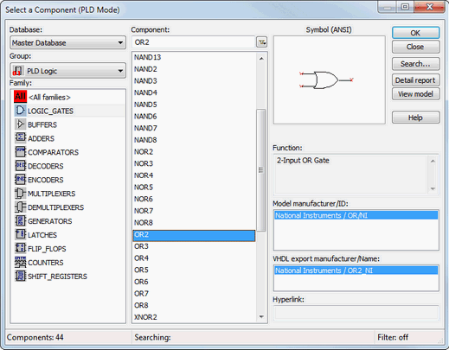

Example of the use virtual instruments to measure the voltage and the current in a circuit

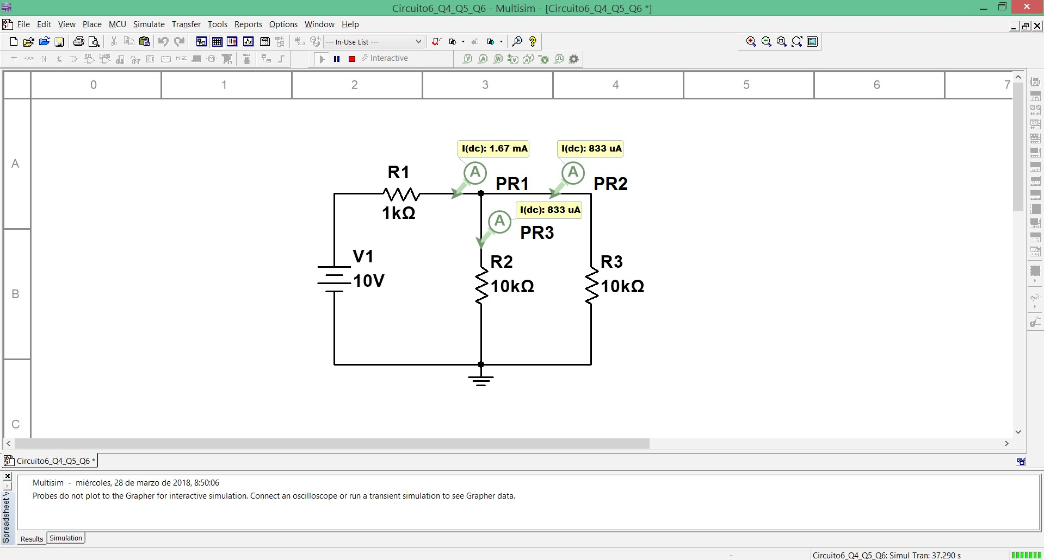

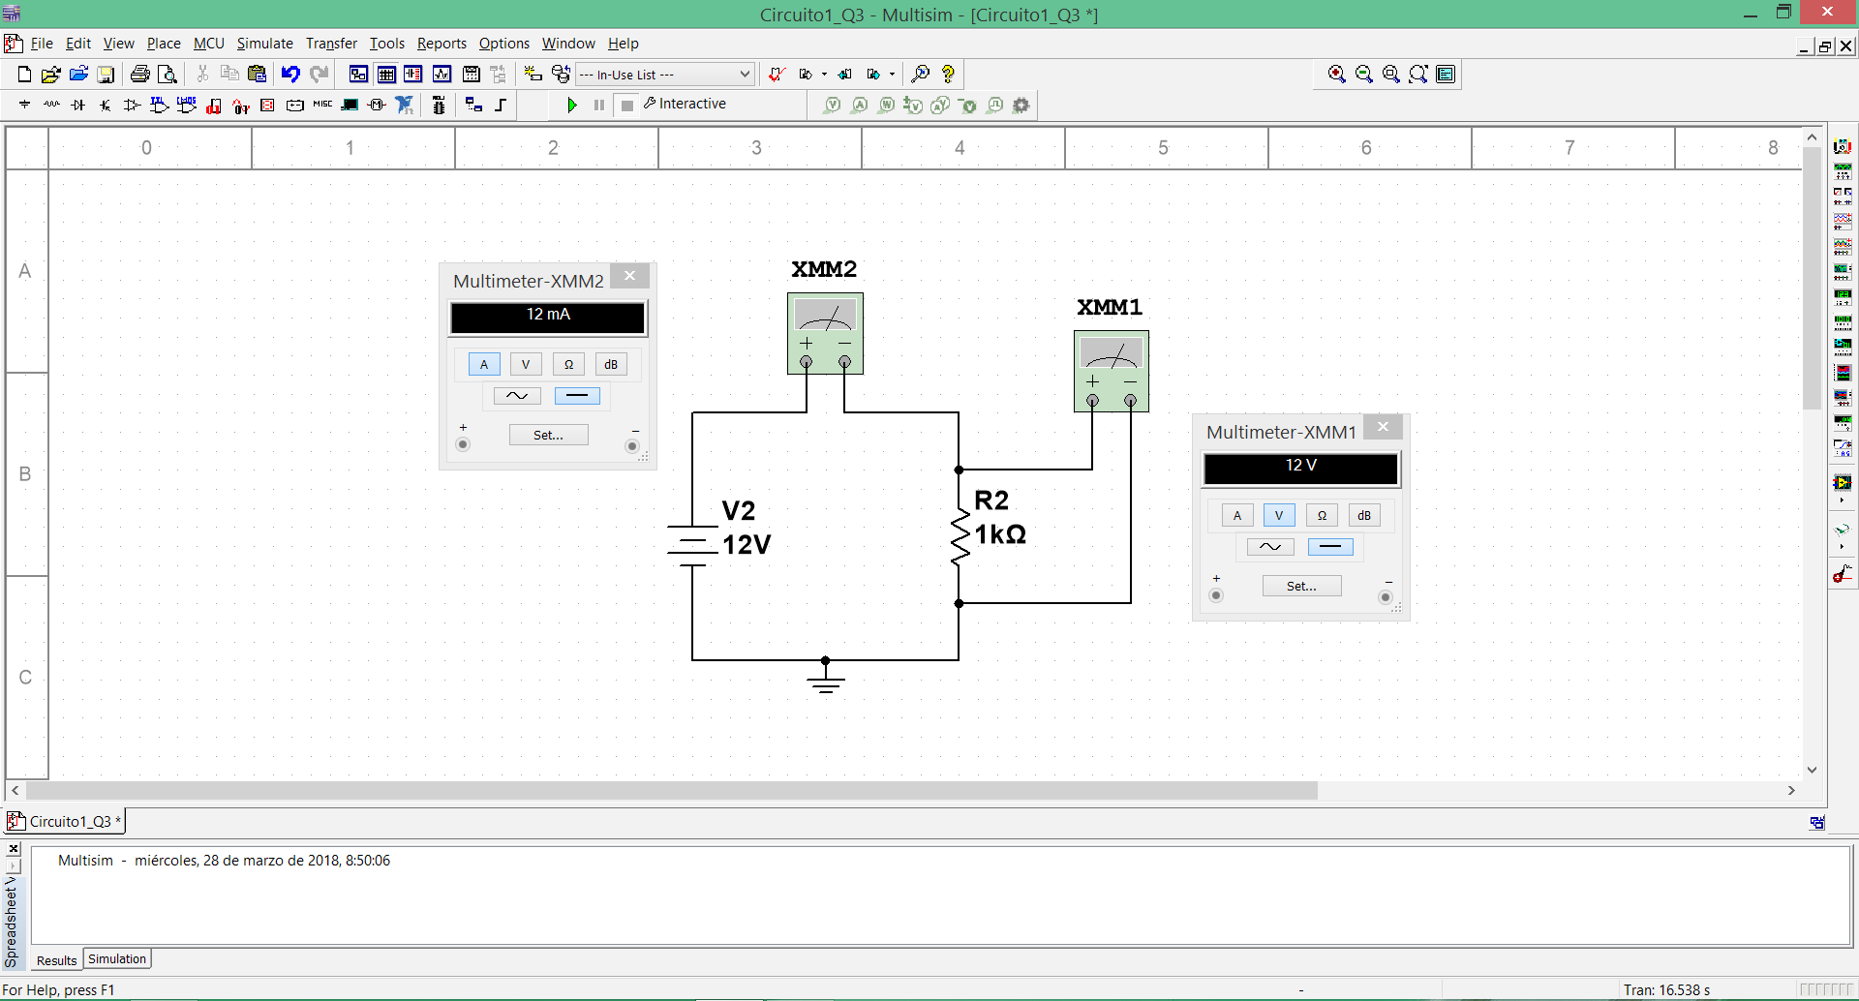

EDIBON DEVELOPMENT KIT FOR CIRCUITS SIMULATION, POWERED BY NI LABVIEW™
MAIN SCREENS

Using the virtual oscilloscope to compare the voltage and current of the same signal

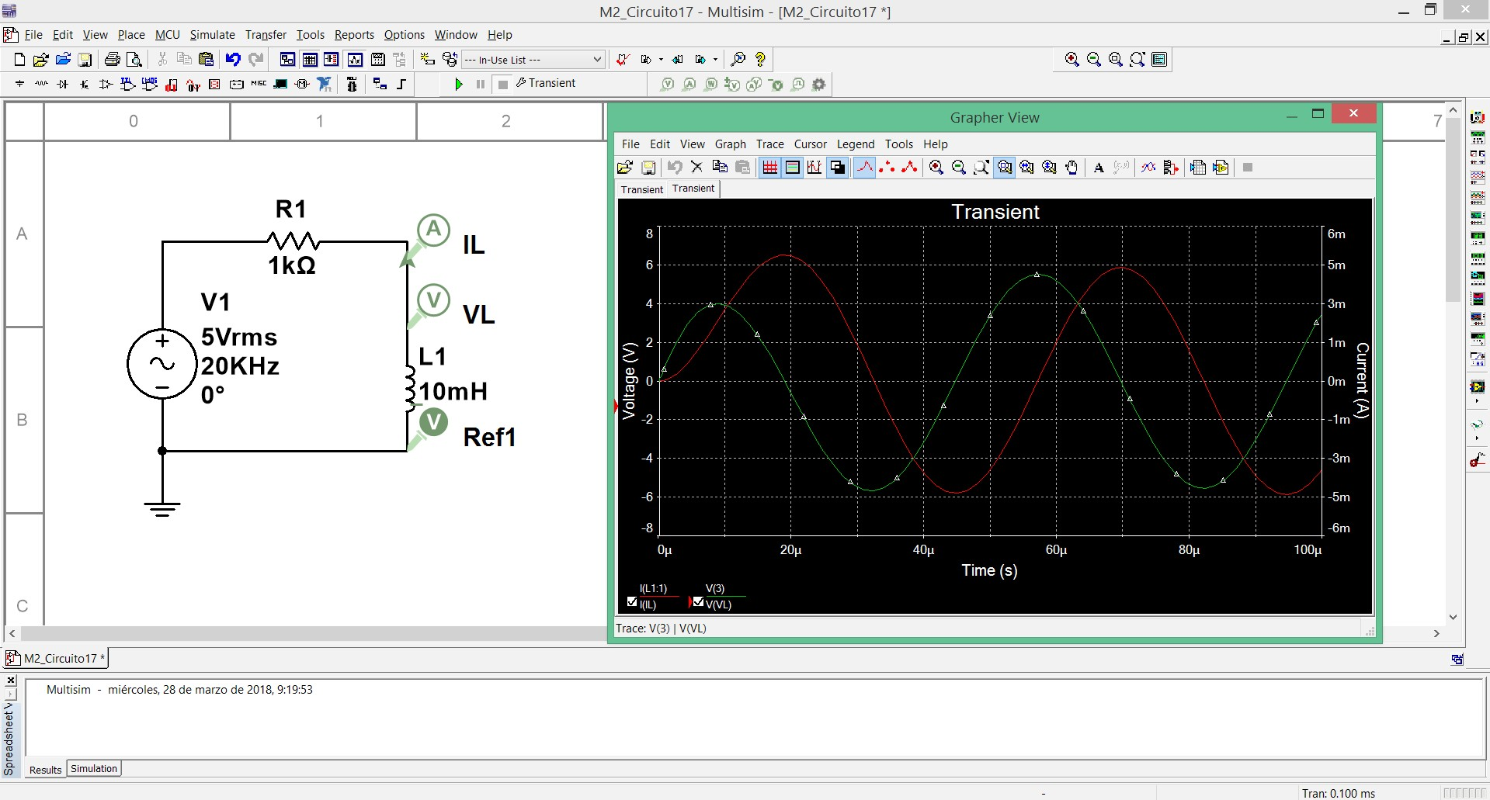

Using the current sweep to analyze the response of a component to different currents

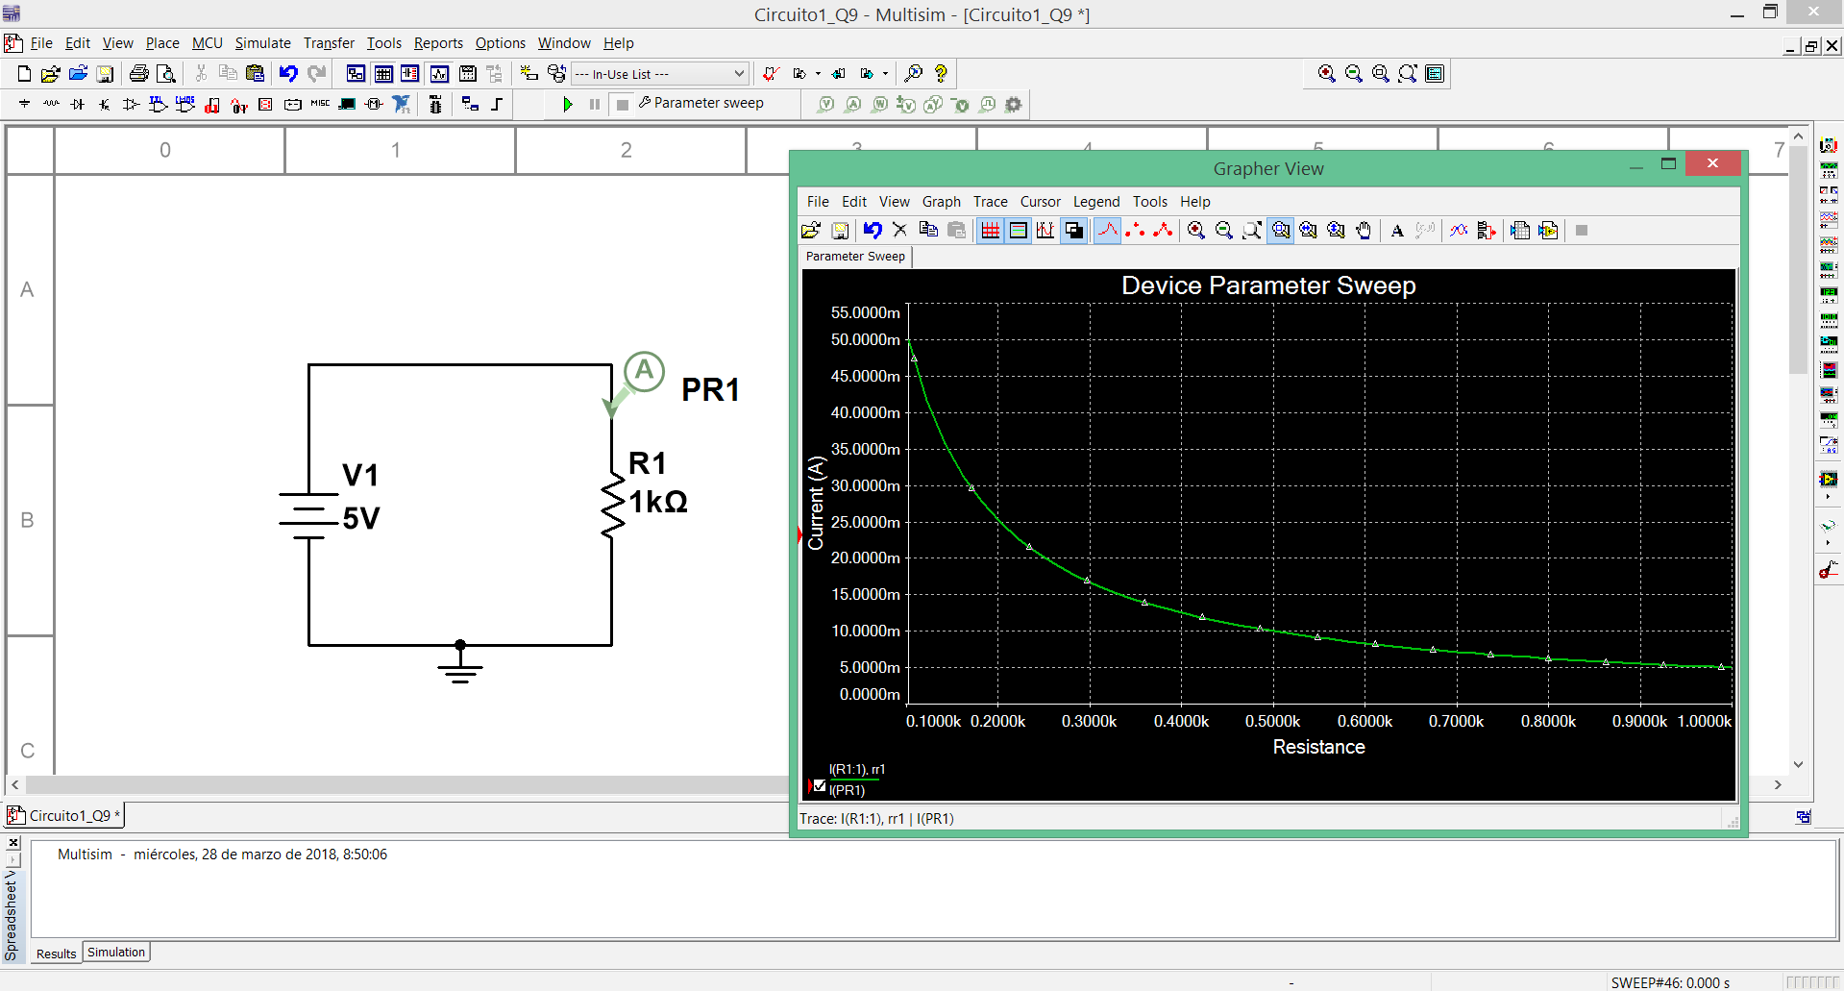

Using the frequency sweep to analyze the response of a RLC circuit (in band pass filter configuration) to different frequencies

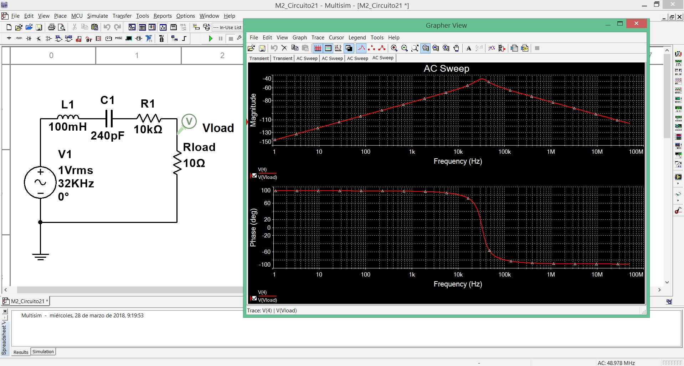

EDIBON DEVELOPMENT KIT FOR CIRCUITS SIMULATION, POWERED BY NI LABVIEW™
MAIN SCREENS

Transient response of a first order system to a step input signal
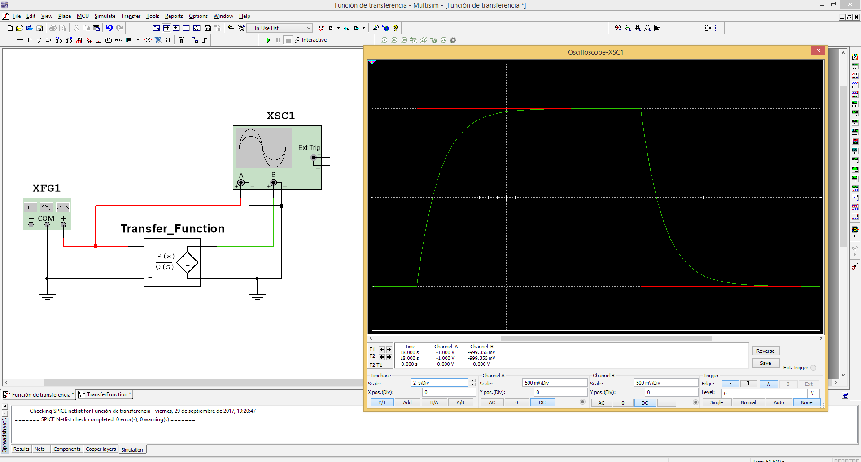

Transient response of a second order system to a step input signal
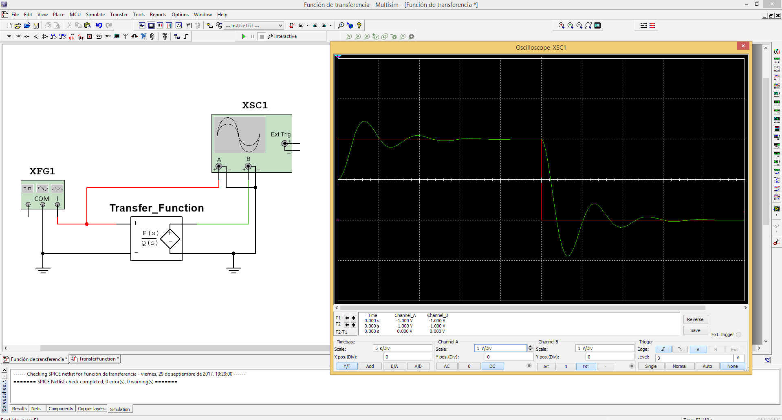

PID control of a second order system
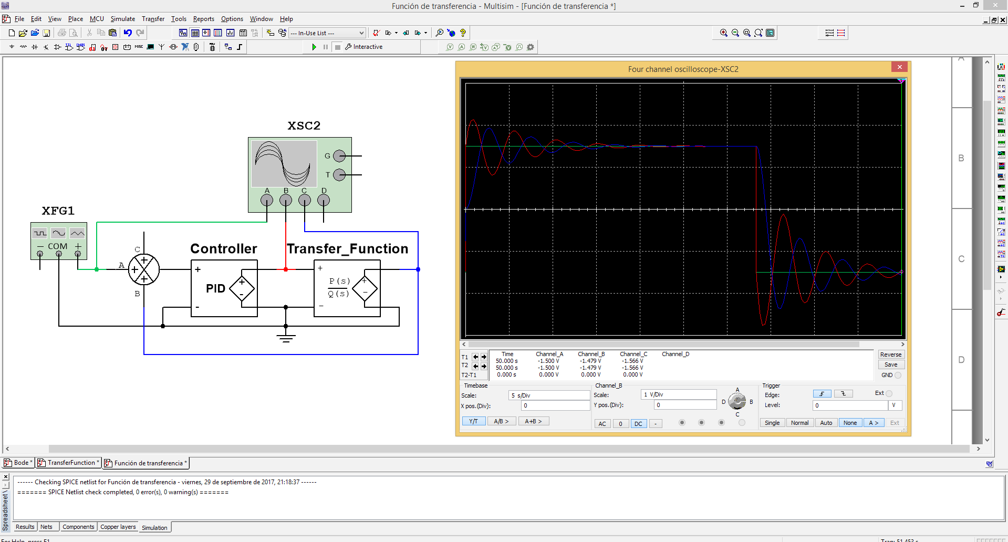

EDIBON DEVELOPMENT KIT FOR CIRCUITS SIMULATION, POWERED BY NI LABVIEW™
MAIN SCREENS

The following picture shows the simulation of a real oscilloscope to test different points of a 555 timer circuit

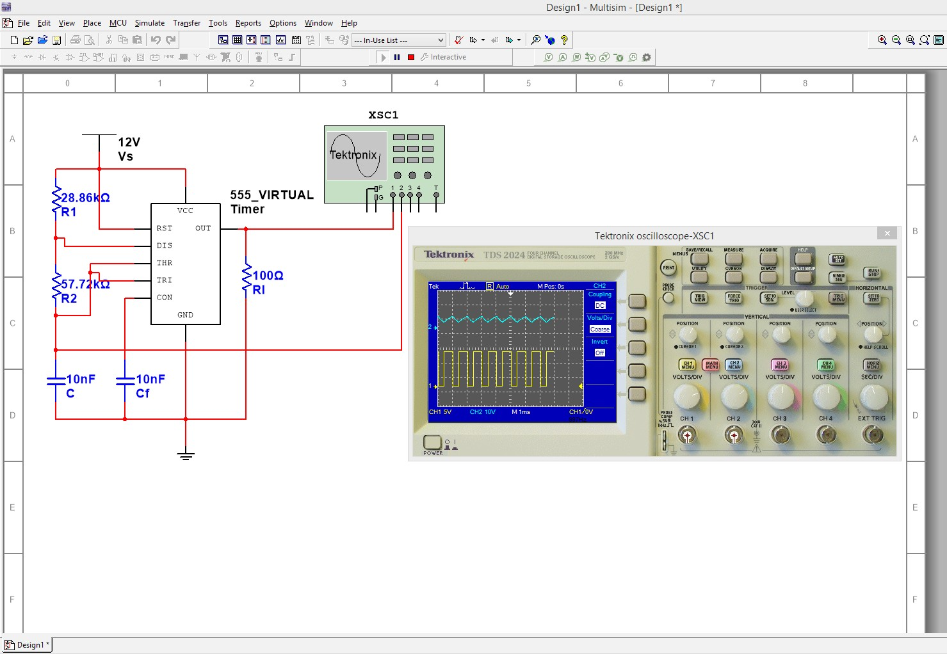

Using a simulation of a real function generation and oscilloscope to test an operational amplifier circuit
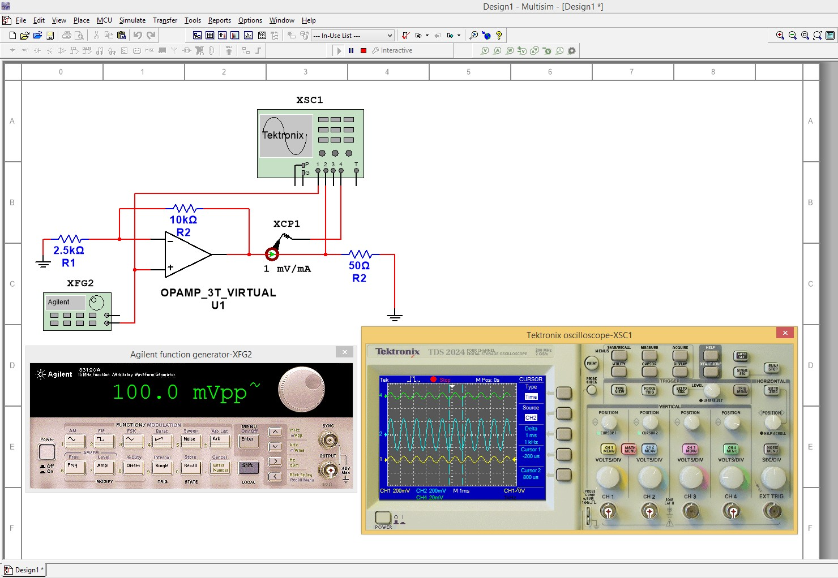

Testing a filling a tank process with simulated real instrumentation
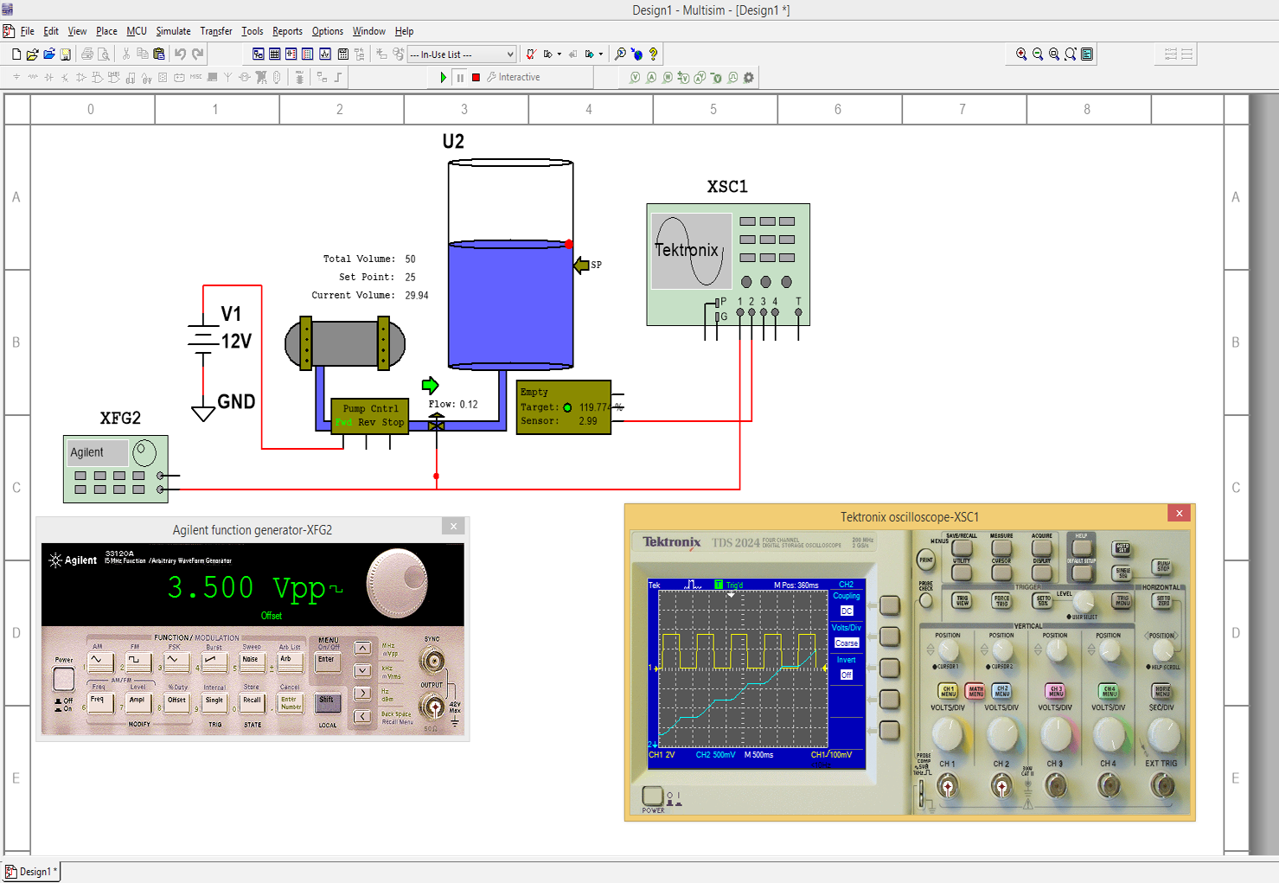

ORDER INFORMATION

• Contact EDIBON Sales Force to consult prices and availability of:

Practical exercises and set of programs.

8

