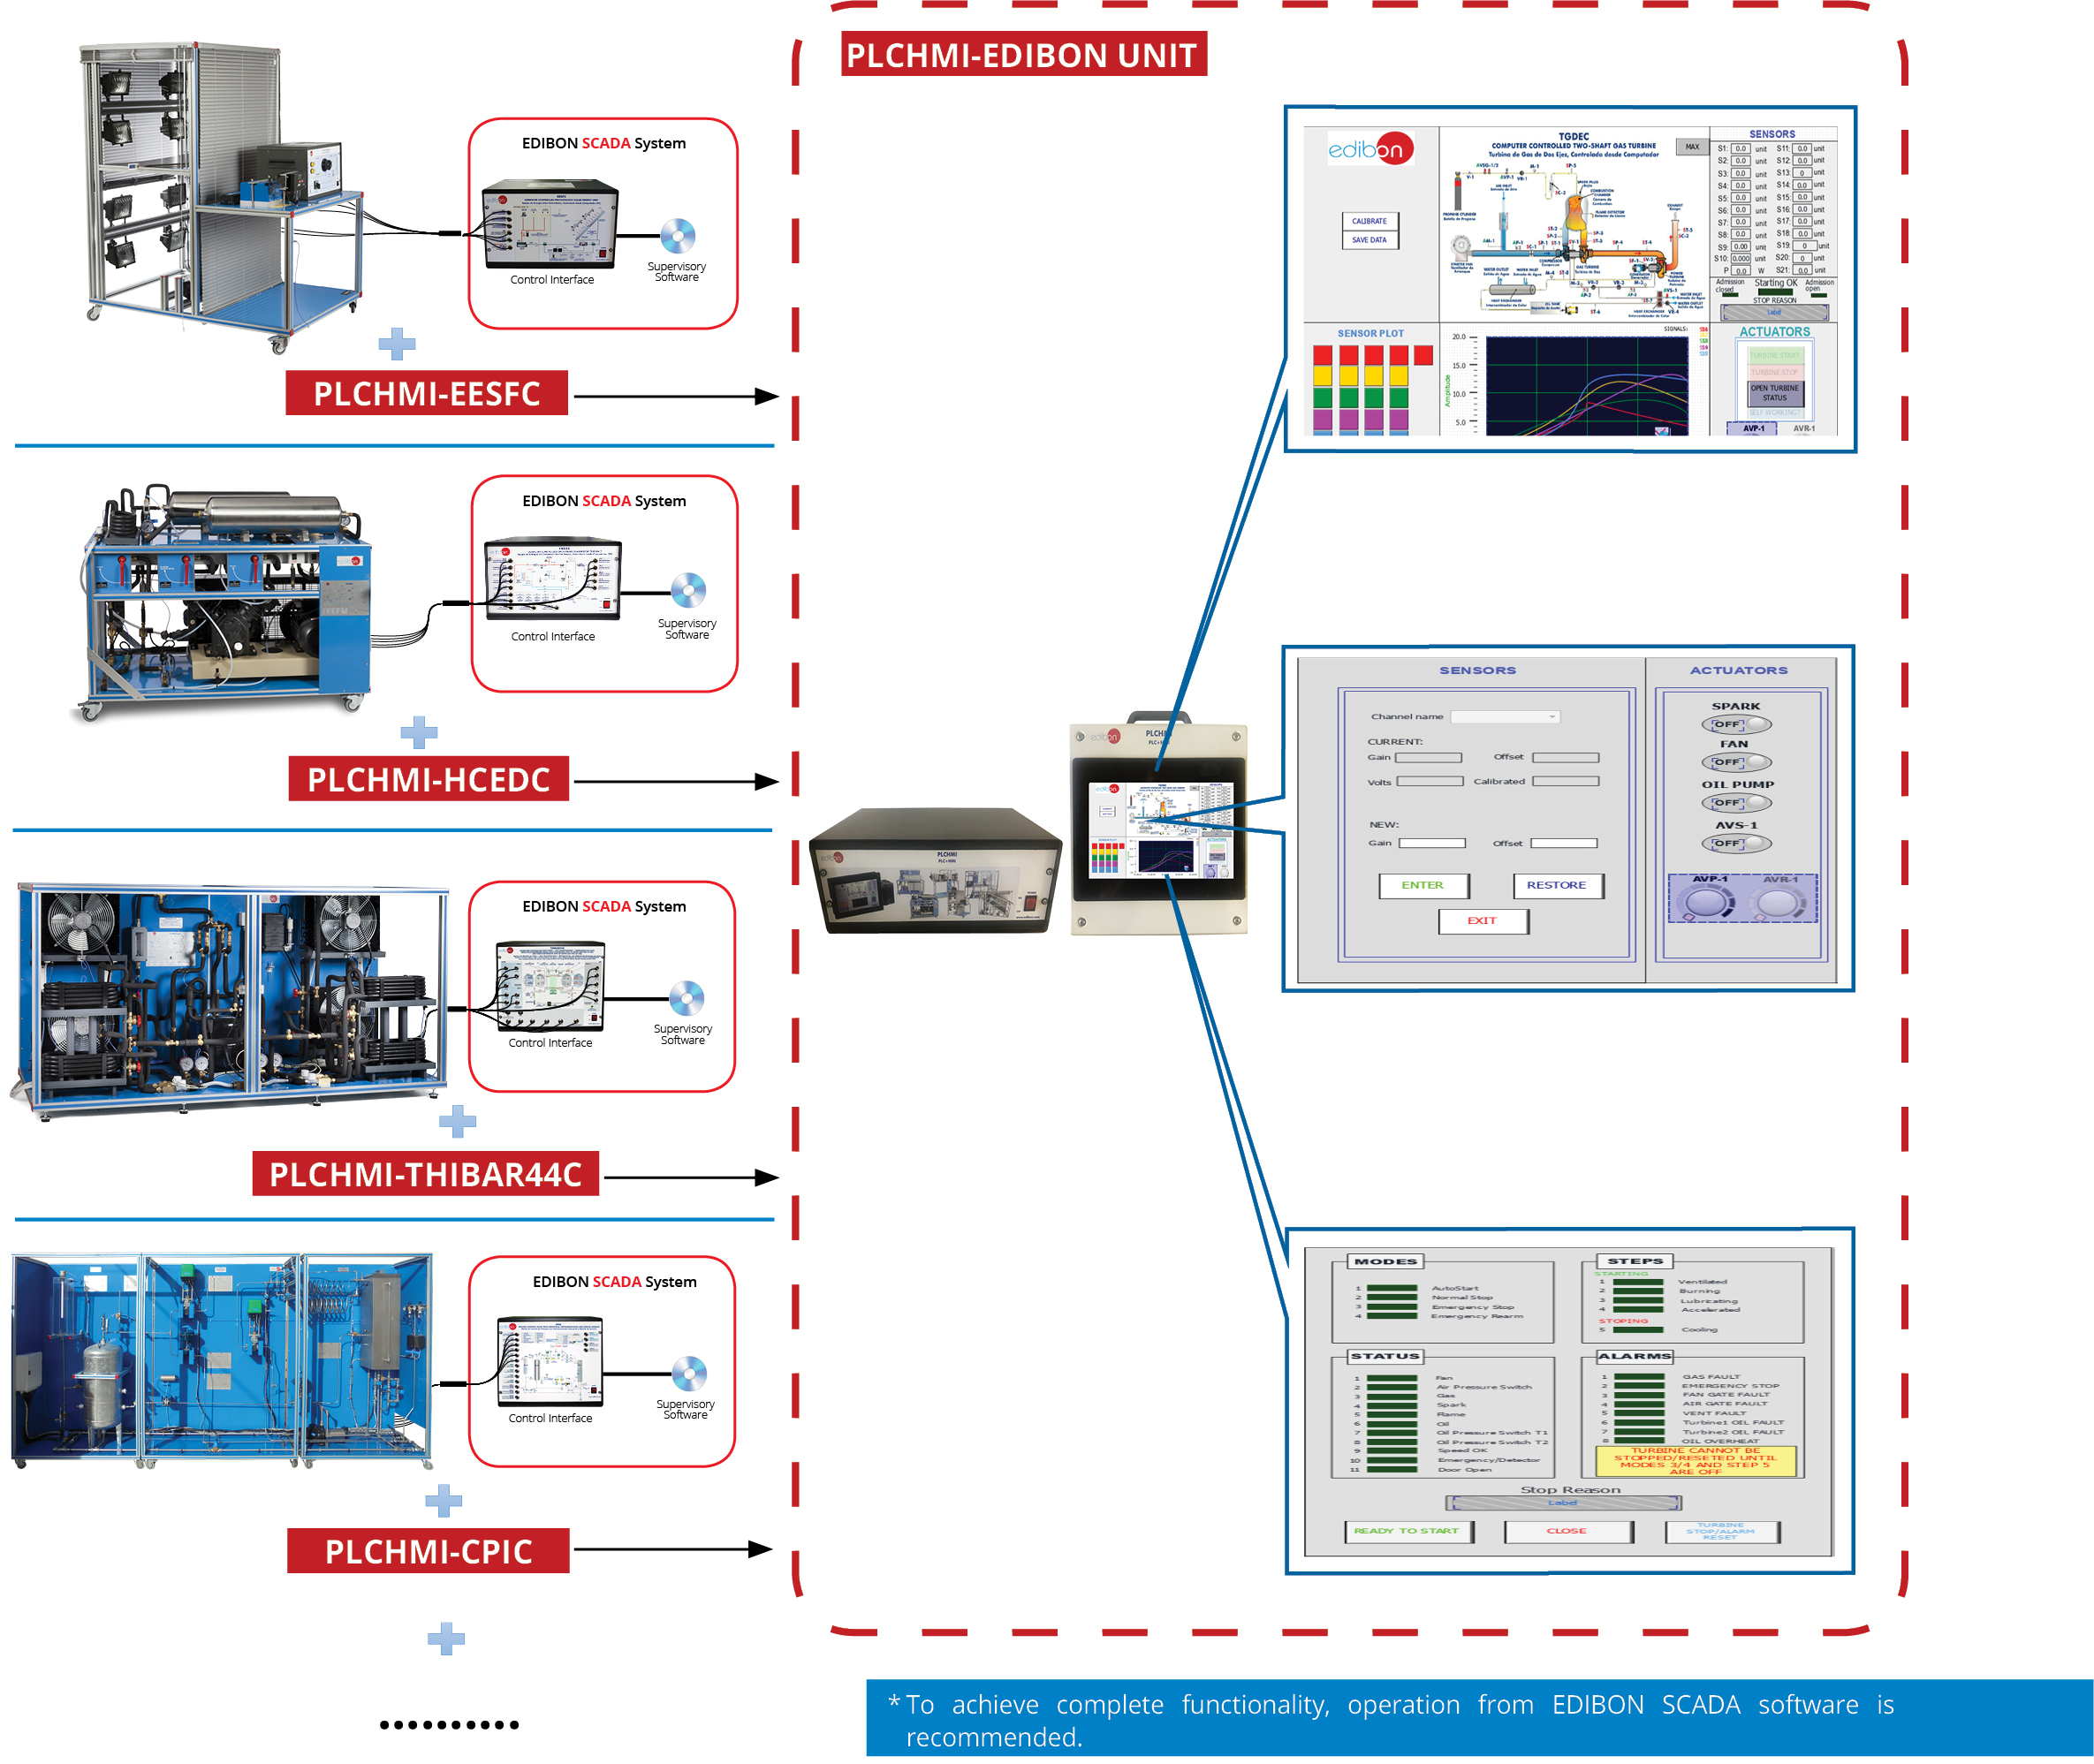

CEDC

Key features:

• Compact interface based on an industrial Programmable Logic Controller (PLC).

• Portable touch screen with a Human Machine Interface (HMI) to provide local or remote control (interface and HMI connection through ethernet cable).

• Possibility to simultaneously operate from HMI and PC.

• Possibility to migrate the HMI software application to smart devices such as smartphone, tablet, etc for remote control.

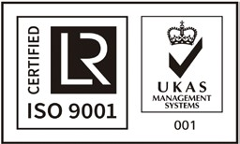

ISO 9001: Quality Management (for Design, Manufacturing, Commercialization and After-sales service)

European Union Certificate
(total safety)

Certificates ISO 14001 and ECO- Management and Audit Scheme (environmental management)
1
“Worlddidac Quality Charter” and Platinum Member of Worlddidac

INTRODUCTION

Today, many industrial applications are controlled by programmable logic controllers (PLCs). The PLC can be considered a purpose-built computer. The PLC has many advantages over other control systems, including flexibility, low cost, operating speed, reliability and ease of programming. These PLCs, in many applications, are accompanied by HMI (Human Machine Interface) in order to monitor and control the industrial process locally.

The expansion for PLC and HMI, “PLCHMI”, is the PLC-HMI set designed by EDIBON. Its objective is to work together with any other EDIBON unit that carries out the control of a process. It allows the user to operate and control EDIBON equipment from a HMI and/or from the EDIBON SCADA software.

GENERAL DESCRIPTION

The expansion for PLC and HMI, “PLCHMI”, is a system composed of an interface that includes PLC modules such as CPU, digital I/O
module, analog I/O module, communications module, etc. and a control box with HMI display.

The PLC interface is the module that contains the PLC controller, different analog and digital I/O modules and the necessary communication modules to communicate with different devices such as HMI, PC, tablet, etc. To communicate with the HMI and/or a PC, the equipment has two Ethernet ports. There is also a SCSI connector to connect the PLC interface with equipment that carries out process control. In addition, the PLC interface could be provided with any other connector or communication port (USB, DB-9 or DB-25 serial connector, etc.) to establish a communication between the expansion and the process control unit.

The HMI control box contains a touch panel to monitor and control the process control equipment. By means of the HMI screen the variables and results of the process can be visualized graphically as well as to control the different actuators. Communication with the control interface is via Ethernet.

SPECIFICATIONS

• PLC interface:
Electrical supply:
Single-phase 100 - 240 VAC, PH+N+G.
Magneto-thermal differential, 2 poles, 25 A, 30 mA AC 6 KA. PLC controller:
Panasonic FP7 CPS31E CPU. Digital I/O modules:
16 digital inputs; Input range 0 V to 24 V.
16 digital outputs; Relay output. Analogue I/O modules:
16 analog inputs; 16-bit resolution. Input range -10 V to +10 V.
4 analog outputs; 16-bit resolution. Output range -10 V to +10 V. Connectors and Communication Ports:
2-Port Ethernet Switch. SCSI connector.
USB, DB-9 Series or DB-25 (if required).

• HMI control box:
Electrical Supply:
Single-phase 100 - 240 VAC, PH+N+G. HMI display:
Touch Screen: Analog Resistive. Size: 10” 16:9 TFT.
Resolution: 1024 x 600, WVGA. Colors: 64 K.
Ethernet port.

DIMENSIONS AND WEIGHTS

PLCHMI:
- Dimensions: 490 x 330 x 175 mm approx. (19.29 x 12.99 x 6.88 inches approx.).
- Weight: 6 kg approx. (13 pounds approx.).

EDIBON SOFTWARE PLCHMI EXPANSION MAIN SCREENS

Example of an HMI SCADA interface

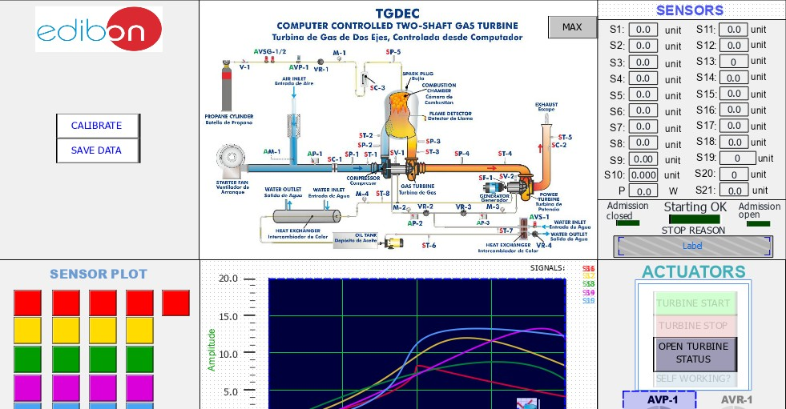

Example of an HMI SCADA interface

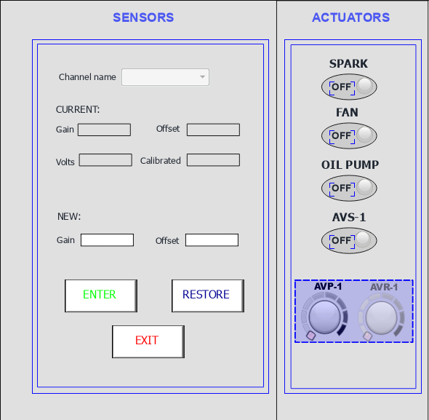

EDIBON SOFTWARE PLCHMI EXPANSION MAIN SCREENS

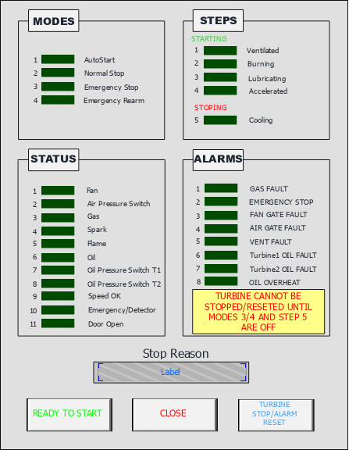

AVAILABLE WIDE RANGE OF PLCHMI APPLICATIONS (PID CONTROL)

Units which can use PLCHMI:
Examples:

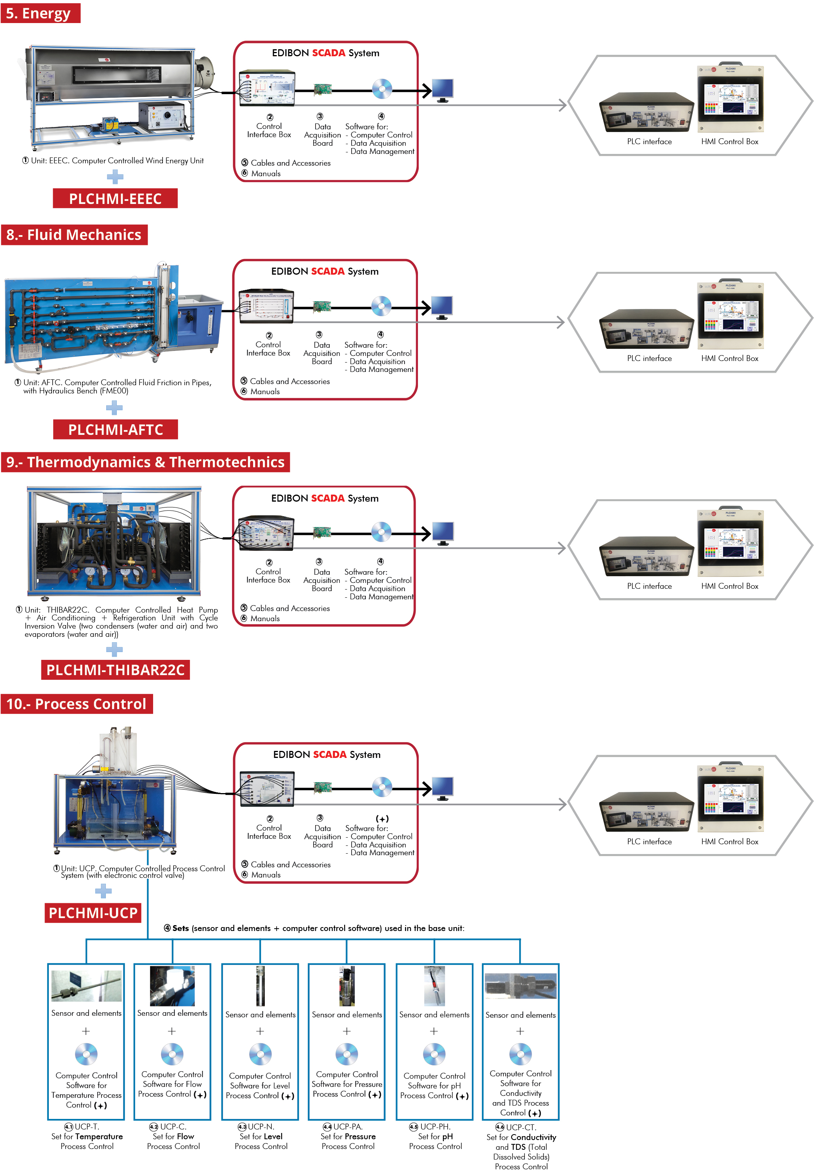

Process Control

AVAILABLE WIDE RANGE OF PLCHMI APPLICATIONS (PID CONTROL)

Units which can use PLCHMI:
Examples:
